Microsoft Edge in IE Mode.
Any one of the options below can be used to set up Edge with IE Mode settings.
Option 1: IE-Mode by Organization: Add a group policy and deploy it to clients. Setting up Microsoft Edge policy is the same as shown for Option 2.
Option 2: IE-Mode by Local Policy.
Steps
- Install Microsoft Edge Policy Templates.
- Create a sitelist.xml to define sites we want to open in the IE-Mode tab
- Set appropriate policies in the Local Group Policy Editor.
Option 3: Edge Browser user settings: This option requires a user to turn on the IE mode setting in the Edge browser and add the list of URLs to ‘Internet Explorer mode pages’. Added URLs are opened in IE mode for 30 days after which the URLs must be added again to the browser.

SRC: https://docs.microsoft.com/en-us/DeployEdge/edge-ie-mode-policies

Detailed Steps to setup Edge in IE Mode.
Option 2: IE-Mode by Local Policy
Step 1: Download the latest Microsoft Edge Policy Template files from the Microsoft site.
To download from the Microsoft site, go to the below URL and select the latest build options as shown in the screenshot below, and click on ‘Get Policy Files’.
URL: https://www.microsoft.com/en-us/edge/business/download
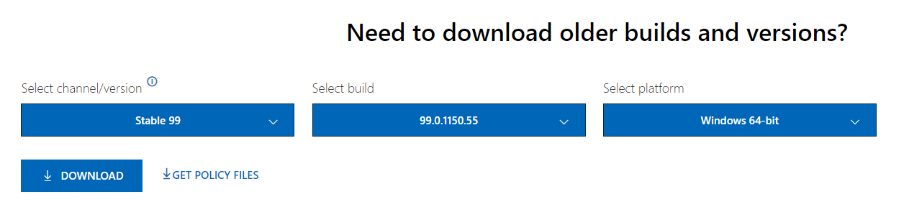

Copy ‘msedge.admx’ file from MicrosoftEdgePolicyTemplates\windows\admx to C:\Windows\PolicyDefinitions
For en-US locale, Copy ‘msedge.adml’ file from MicrosoftEdgePolicyTemplates\windows\admx\en-US to your system locale folder C:\Windows\PolicyDefinitions\en-US

Step 2: Create a file sites.xml with the URLs that need to be opened in IE Mode.
<site-list version="1.0">
<created-by>
<tool>EMIESiteListManager</tool>
<version>10.0.14357.1004</version>
<date-created>03/31/2022 09:55:26</date-created>
</created-by>
<site url="lifetrak2015.wellsky.com:9001/forms/java/donor.html">
<open-in>IE11</open-in>
</site>
<site url="lifetrak2015.wellsky.com:9001/forms/java/lab.html">
<open-in>IE11</open-in>
</site>
<site url="lifetrak2015.wellsky.com:9001/forms/java/oraforms.html">
<open-in>IE11</open-in>
</site>
</site-list>

Step 3: Setting the policies in the local group policy editor.
- Open ‘Local Group Policy Editor’ by entering gpedit.msc in the windows run dialog (Win + R)

- Configure Internet Explorer integration
  - Go to ‘Microsoft Edge’ policy as shown in the screenshot below (User Configuration/Computer Configuration > Administrative Templates > Microsoft Edge ) and double-click the ‘Configure Internet Explorer integration’ policy.

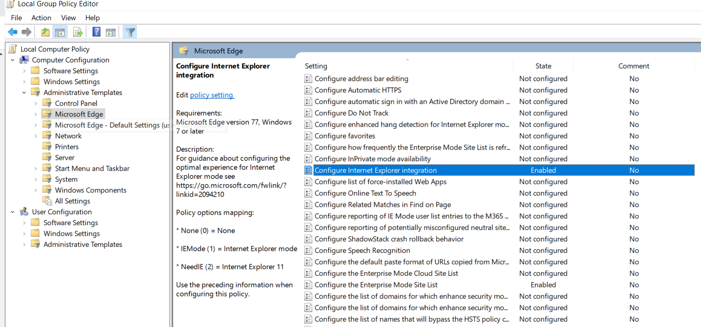

  - Select the Enabled option and under options select ‘Internet Explorer mode’ as shown in the below screenshot.

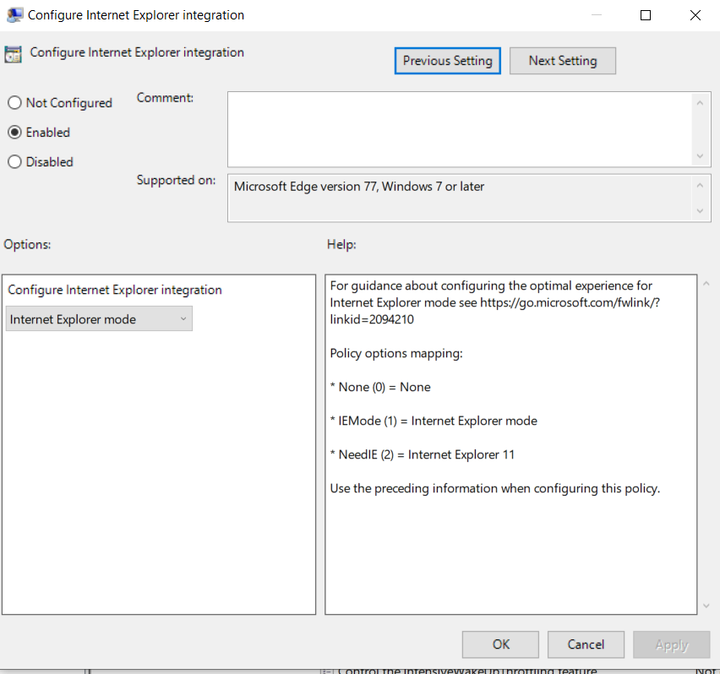

- Configure the Enterprise Mode Site List policy
  - Go to ‘Microsoft Edge’ policy as shown in the screenshot below (User Configuration/Computer Configuration > Administrative Templates > Microsoft Edge ) and double-click the ‘Configure the Enterprise Mode Site List’ policy.
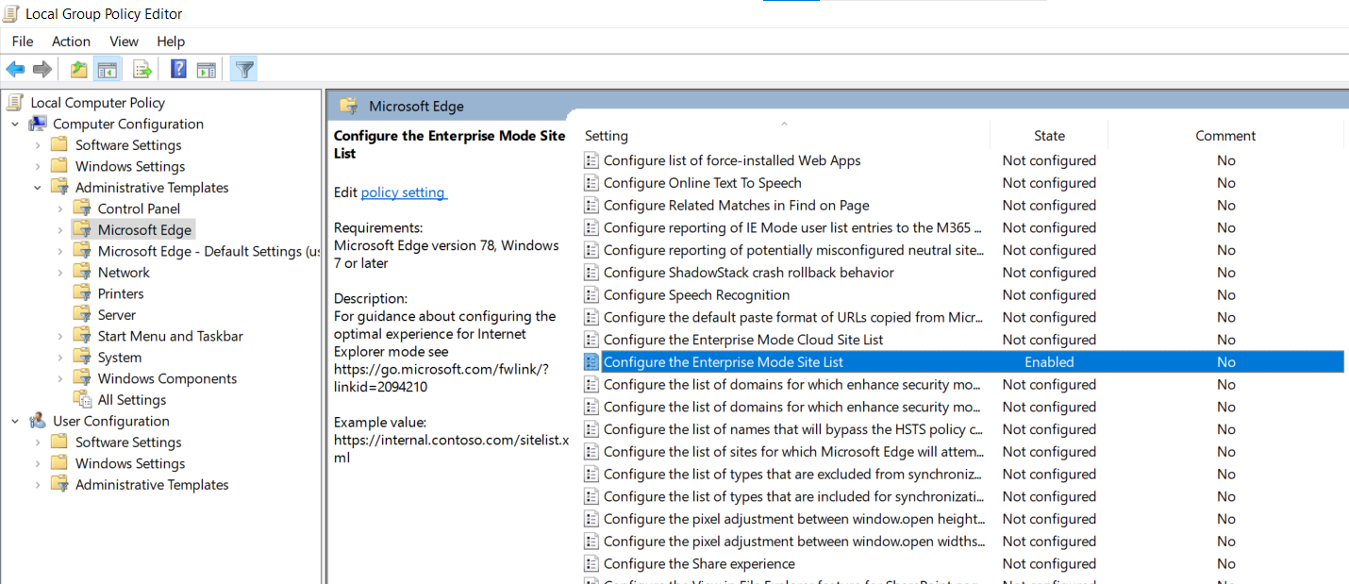
  - Select the ‘Enabled’ option and under options give the path to sites.xml as shown below.
The path can be HTTPS location, local network file, or a local file.
Eg:
- HTTPS location: https://iemode/sites.xml
- Local network file: \\network\shares\sites.xml
- Local file:
C:\Users\<user>\Documents\sites.xml
Or
file:\\\C:\Users\<user>\Documents\sites.xml

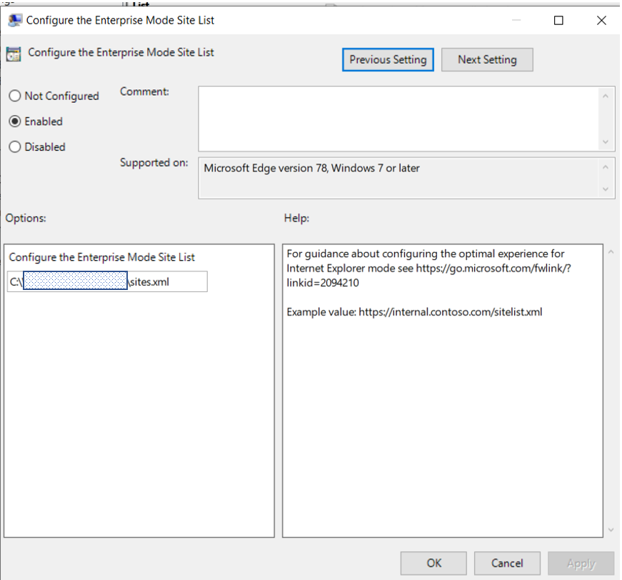
- Verify that changes are loaded correctly by entering “edge://policy” in the address bar. If the policies are not shown, restart the machine and try again.
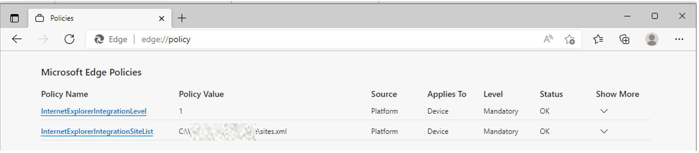
Application is launched in Edge IE Mode.
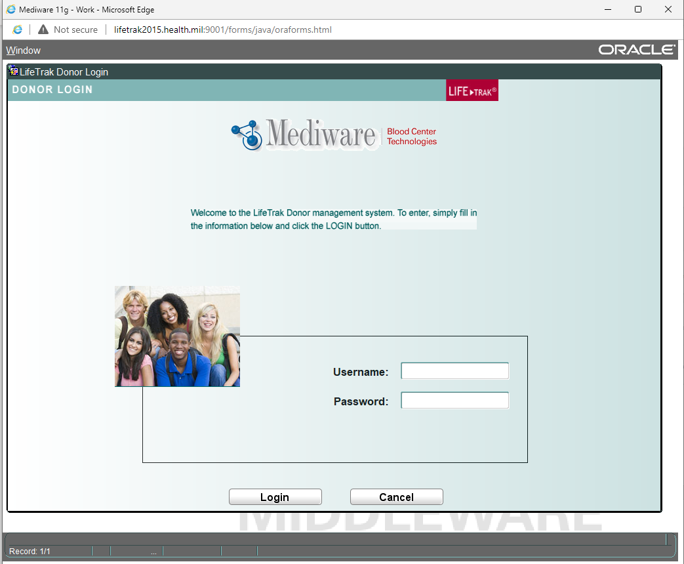

Option 3: Edge Browser user settings
- Open the Microsoft edge Settings Default browser

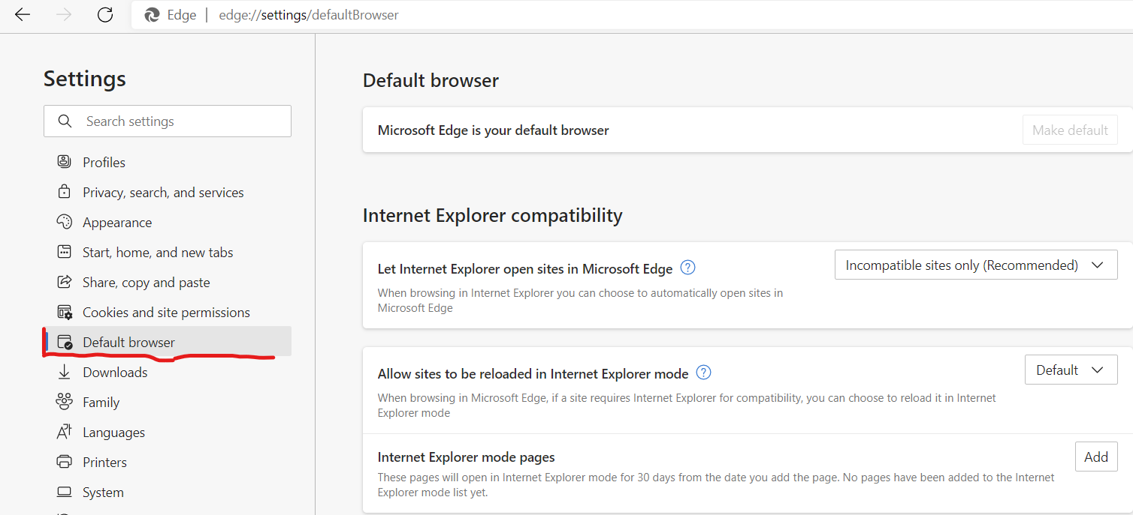

- In Internet Explorer compatibility Allow site to be reloaded in Internet Explorer mode change from default to Allow & click Restart button

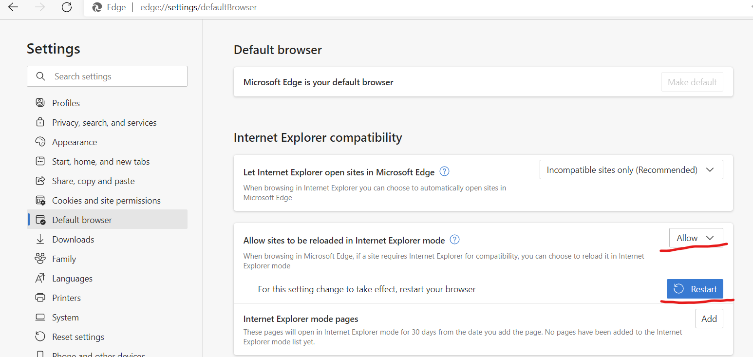

- Click Add Button, it will popup for Add Page for Application URL, Enter the Blood Center 2015 Application URL

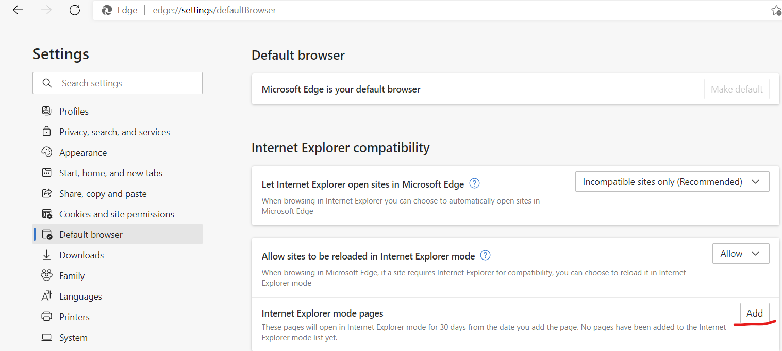

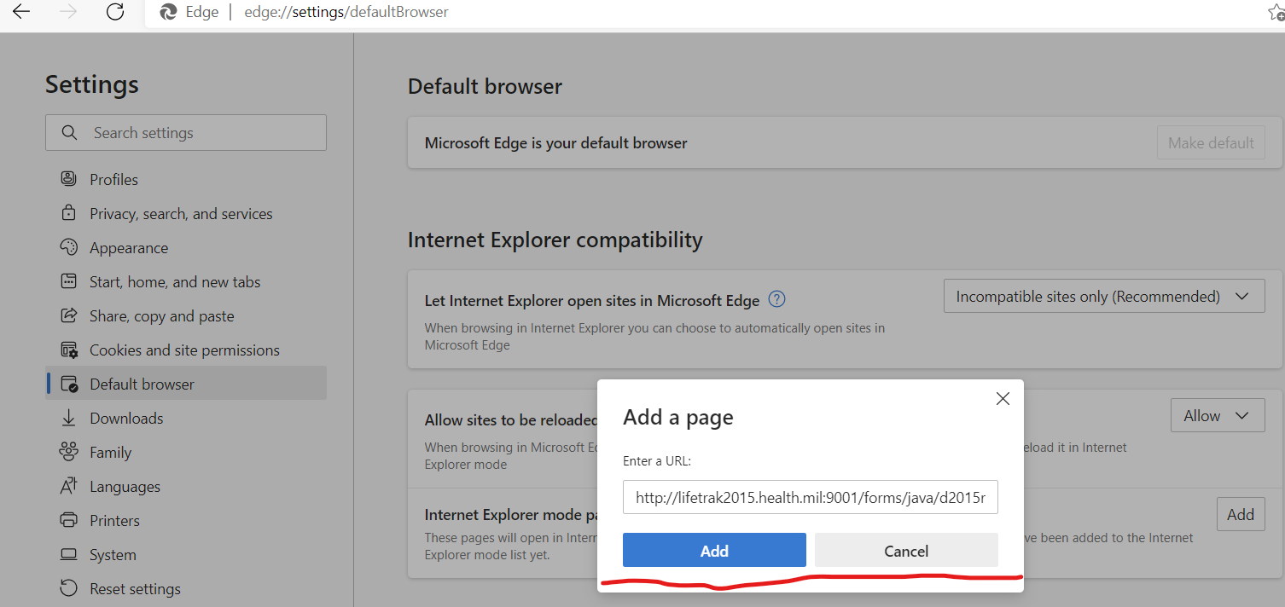

- Click Add

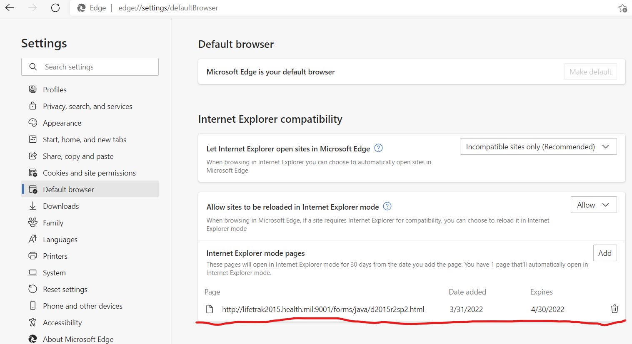

- This URL is valid for 30 days after adding date, you need to readd this link by 30 days of time for continuing the IE mode for this application.
- Open the Blood Center Application in IE Edge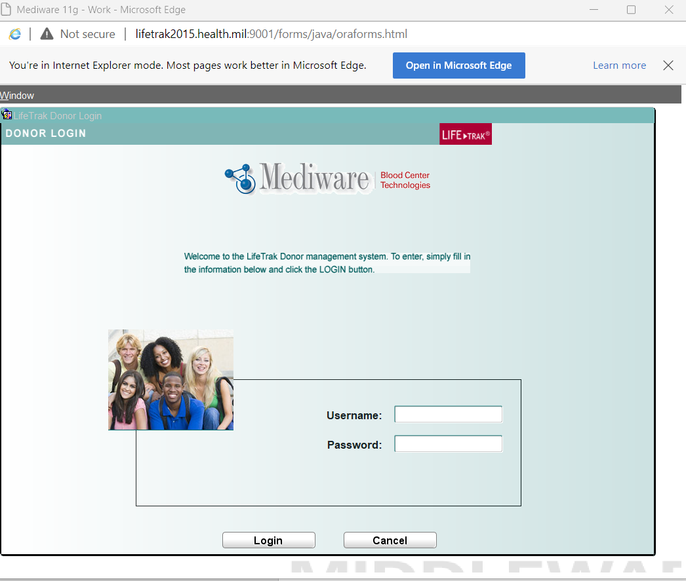

Modification History
Date | Change | By
04/04/2022 | Set up instructions for Edge browser to allow BC2015 application. (IE Mode option for Edge browser)  Release: 2015 R4 SP5 | Ashok Vardhan  Seshu Surapaneni

